

INTERNSHIP REPORT

A report submitted in partial fulfillment of the requirements for the Award of Degree of

# BACHELOR OF COMPUTER APPLICATIONS

## Under

**BENGALURU CITY UNIVERSITY**

**Submitted By**

**Snehal Kumari**

**Under the Guidance of**

**Mr. Mrinal Kanti Halder** **Ms. Jyothsna**

**Supervisor Assistant Professor**

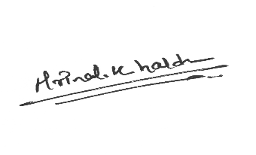

**Signature Signature with Seal**

**Internship Offer Letter**

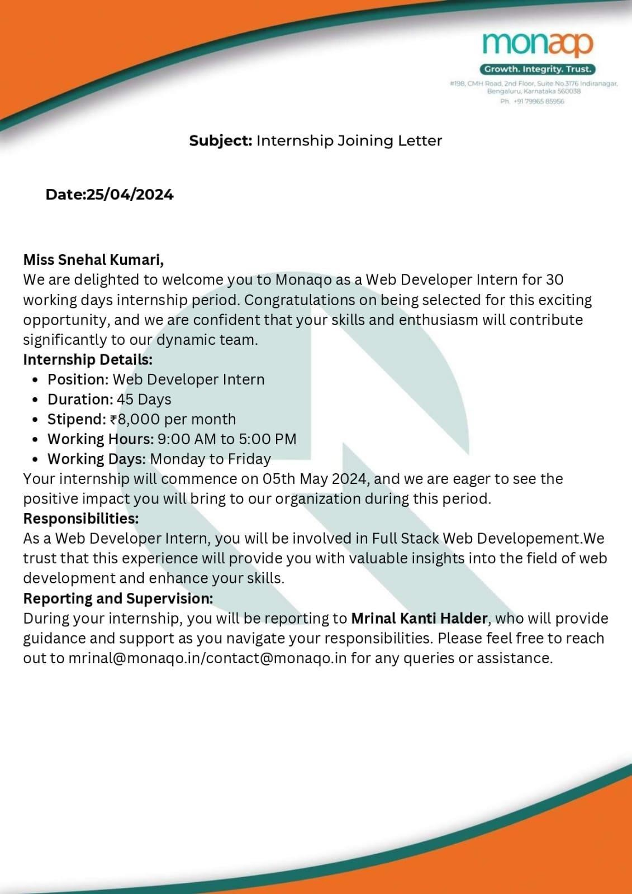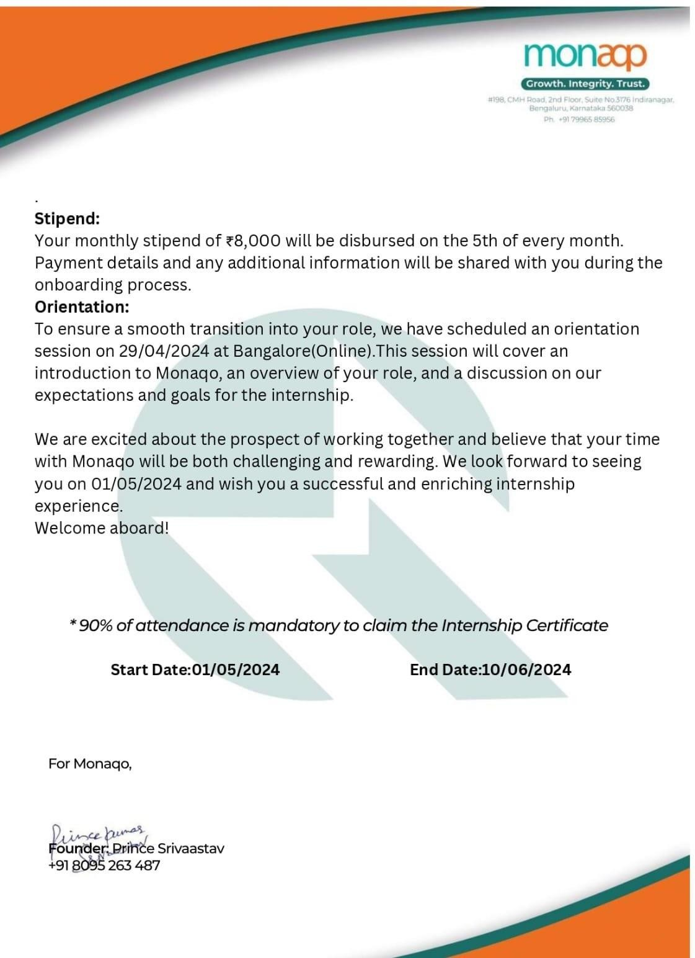

**Internship Completion Certificate**

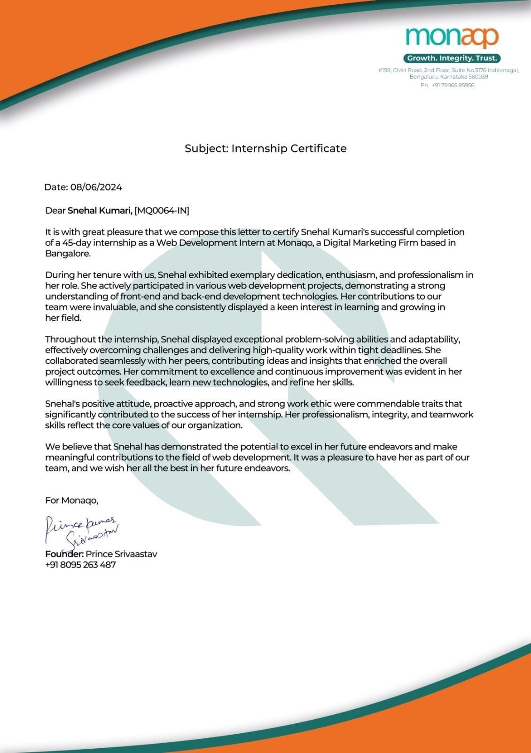

# DECLARATION

I Snehal kumari, bearing Reg.No: U18FY21S0108 student of 6th semester BCA, **Sambhram Academy of Management Studies, Bengaluru,** hereby declare that the internship entitled **“Web Developer”** has been caried out by me under the supervision of **Mr. Mrinal Kanti Halder** at Monaqo ,a Digital Marketing Firm based in Bangalore and Internal guide **Prof. Ms. Jyothsna** Department of Computer Applications, SAMS and submitted in partial fulfillment of the Degree of Bachelor of Computer Applications by the Bengaluru City University during the academic year 2023-2024. This report has not been submitted to any other Organization/University for any award of degree or certificate.

Name of the Student: Snehal kumari Reg. No: U18FY21S0108

Signature:

Place: Bengaluru Date:24/06/2024

# ACKNOWLEDGEMENT

I have put in lot of efforts in this project. However, it would not have been possible without the support of many people.

I would like to thank all of them. I express my sincere thanks to our honorable principal **Wg.Cmdr. Dr. K Srinivas Rao**, Principal for permitting me to undertake this project as part of our curriculum.

I would like to thank **Prof. Ms. Sunitha. K HoD**, Department of Computer Applications, for her immense support and guidance throughout the project.

I am indebted to my guide **Prof. Ms. Jyothsna**, Department of Computer Applications, Sambhram Academy of Management Studies, Bengaluru, who has helped me with her useful guidance in completing this task through various stages. It gives me an immense pleasure to extend my thankfulness to all my Teaching fraternity of Department of Computer Applications for their suggestions and encouragement throughout my internship work.

I also would like to express a deep sense of gratitude to **Mr. Mrinal Kanti Halder ,** Supervisor, for his continuous support, valuable information and challenging efforts in the right direction.

Last, but not the least, I thank Almighty, my beloved parents and friends for their persistent encouragement.

Thanking You. Snehal Kumari

## Abstract

I was provided an opportunity to undertake an internship as a Web Development Intern at Monaqo , a Digital Marketing Firm based.

Website Design and learning were the main objective of this internship. To develop a web based application there are several applications or programming language that are in use. Some of them are only used for the frontend and backend design of the software. For example, **HTML, CSS, Bootstrap, JavaScript** etc. There are also some other programming languages that are used to develop the dynamic functions of the software or application. For example- Java etc.

This report takes us through all the details of **WEBSITE DESIGN & DEVLOPMENT** knowledge and experience gathered during this internship period.

This internship provided essential skills and knowledge one requires in the field of web designing. The crucial tools used during the tenure helped me in gaining knowledge about website development . By taking this training ,it enhanced knowledge in Web designing and got insight in how the websites are designed responsiveness.

It helped me to enhance my communicative skills and represent my work .

**SAMBHRAM ACADEMY OF MANAGEMENT STUDIES**

(Affiliated to Bengaluru University, Karnataka)

MS Palya, Vidyaranyapura post, Bengaluru – 560097

Department of Computer Application

Certificate

I Snehal kumari Bearing Reg.No: U18FY21S0108 student of 6th Semester BCA, Sambhram Academy of Management Studies, Bengaluru, hereby declare that the Internship entitled “Web Developer” has been carried out by me under the supervision of Mr. Mrinal kanti Halder, at Monaqo Digital Marketing Firm and Internal guide Ms. Jyothsna Assistant Professor, Department of Computer Applications, SAMS and submitted the as partial fulfillment of the Degree of Bachelor of Computer Applications by the Bangaluru City University during the academic year 2023-24. This report has not been submitted to any other Organization/University for any award of degree or certificate.

Signature of Internal Guide:

Head of Department

**Mrs. Sunitha. K**

Head of the Department of Computer Applications

Bengaluru - 560097

**Ms. jyothsna**

Assistant professor

Department of Computer

Applications

Bengaluru – 560097



### INDEX

|  |  |  |
| --- | --- | --- |
| **Sl. No** | **Particulars** | **Page Nos.** |
| 01 | Overview | 09 |
| 02 | Title Page | 12 |
| 03 | Introduction about the Company | 15 |
| 04 | Weekly overview of the Internship | 17 |
| 05 | Skills acquired during the Internship | 19 |
| 06 | Conclusion | 26 |

**OVERVIEW**



##### INTRODUCTION :–

**WEB DEVELOPMENT**

W e b d e v e l o p m e nt is the w o r k i n v o l v e d in d e v e l o p i n g a web s i t e or t he I n t e r n e t . W e b development can range from developing a simple single static page of plain text to complex web-based internet

applications, electronic businesses, and social network services.

### HTML

HTML stands for Hyper Text Markup Language HTML is the standard markup

language for Web pages HTML element are the building blocks of HTML pages HTML elements are represented by tags

BASIC TERMS: Project stucture:

< !Doctype>

< html>

< body>

.............................................

< /body>

< /html>

* HTML Elements

An HTML element is a start tag and an end tag with content in between:-

<h1> heading tag </h1>

Internship Report Page 9

### CSS

Cascading Style Sheets, fondly referred to as CSS, is a simply designed language intended to simplify the process of making web pages presentable. CSS allows you to apply styles to web pages. More importantly, CSS enables you to do this independent of the HTML that makes up each web page.

There are three types of CSS which are given below:

* Inline CSS
* Internal or Embedded CSS
* External CSS

Below example illustrate the CSS content:

<!DOCTYPE html>

<html>

<head>

<title> HTML 5 Demo</title>

<style>

.intern {

font-size:40px; font-weight:bold; color:green;

}

body {

text-align:center;

}

</style>

</head>

<body>

<div class = "intern">Hello World!</div>

<aside>

<div>This is new web</div>

</aside>

</body>

</html>

Internship Report Page 10

#### JavaScript

JavaScript is a lightweight, cross-platform and interpreted scripting language. It is well-known for the development of web pages, many non-browser environments also use it.

JavaScript can be used

for Client-side developments as well as Server-side developments.

Features of JavaScript:

* According to a recent survey conducted by Stack Overflow, JavaScript is the most popular language on earth. With advances in browser technology and JavaScript having moved into the server with Node.js and other frameworks, JavaScript is capable of so much more.
* Functions in JS are objects. They may have properties and methods just like another object. They can be passed as arguments in other functions.
* Can handle date and time.
* Performs Form Validation although the forms are created using HTML.
* No compiler needed.

#### Bootstrap

Bootstrap is designed to be mobile first, meaning that the classes are designed such that we can begin by targeting mobile device screens first and then work upwards to larger screen sizes. The starting point for this is first through media queries. We have already added the support for media queries in the last lesson, where we added this line to the head:

<meta name="viewport" content="width=device-width, initial-scale=1, shrink-to-fit=no">

The viewport meta tag ensures that the screen width is set to the device width and the content is rendered with this width in mind. This brings us to the second issue, designing the websites to be responsive to the size of the viewport. This is where the Bootstrap grid system comes to our aid. Bootstrap makes available four sizes, xs for extra small, sm for small, md for medium and lg for large screen sizes. We have already seen the basics of responsive design.

Internship Report Page 11

## Title: Experience Of Web Devloper Intern -



**Introduction:**

Being an intern it was my first overall experience that I will be introduce here, This is **Snehal Kumari**, and I am thrilled to join the team as a Web Development Intern. I am currently pursuing my degree in [**Bachelor Of Computer Applications**] at [ SAMS College], where I have been actively involved in learning and developing skills in web development.

I have experience working with various web technologies, including HTML, CSS, JavaScript, and also learning frameworks like React . Through my internship and personal projects, I have honed my abilities in both front-end and back-end development, and I am eager to bring my enthusiasm and knowledge to **[Monaqo].**

**Problem Definition:**

Web development can be a long and complex process with many factors, including both technical and non-technical aspects of website creation. These issues can be resolved with the proper implementation of code and strategy. In summary, we know that there can be many challenges in web development, but this blog has described some of the key challenges to consider…

###### Problem Specification:

**Setting Goals**

There are many challenges in web development. The first thing you have to overcome in a project is clearly define your goals. Goals can affect or reduce the quality of your website or web application. Starting with a specific goal simplifies the process and allows developers to focus on the right direction.

###### Designing &UI

The first thing that catches the viewer’s attention is usually an attractive design. People like to interact with attractive designs as well as web development. Everything created for marketing should be of better quality. This allows you to increase user engagement and conversions. For this reason good web design is essential for any website or app.

###### Speed and Performance

Search engines can provide Google users with thousands of results by searching for just one word .With so many sites to choose from, users don’t have to wait for the site to load. If it takes too long you will be taken to another search result.

###### Working Frame and Knowledge Required

There are some frameworks, programming languages, and equipment to be had withinside the net improvement industry, for constructing networking apps. Selecting the proper form of equipment tools and frameworks can sound easy, however, this is an undertaking many devloper fail to apprehend withinside the early ranges of improvement.

###### Growth and Scalability

Scalability refers to the growth of a web application over time. This is a long-term plan that starts with a basic model and plans to expand in the future reference.

###### Objective of project &Tasks

The website has been developed for company client [marketing based] in an effort to make it as attractive responsive and dynamic as possible. Compared to the existing site a database has been added to our project.

The work of the project is as follows.

* + The first page provides several links. The Home page contains several information about the site like overview home page, about us, testimonials, footer etc.
  + The second page contains information about the details of the service page like what and all service has been provider to the client.
  + The third page provide details about the About us page in which testimonial where also included.
  + The fourth page provides details about the various blogs and news. programs available.
  + The fifth page includes contact and query related information**.**

**Learning Opportunities:**

During my internship period as I have blown up with so many new tech features and skill it help me enhancing my skills knowing about the thing what and all are in the upcoming trends what to use for future reference it is as simple.

#### Feasible study

The initial steps in carrying out a feasibility analysis for a Web project, based on information obtained interactively from a prospective client, are modeled as a rule-based expert system that draws on empirical formulas to provide a quantitative valuation of the client's replies. The model is centered in the pre-design phase, concerned in particular with ascertaining whether coherent aims ,messages, audience, and services have been identified for the Web project. The model is constructed empirically by means of a knowledge-acquisition process. The various data collected from the user are described, as well as the way in which these data are translated into quantitative values that subsequently play a role in the final diagnosis for the Web project. The system has been evaluated int wo ways: system users were asked to provide feedback, and the experts who took part in the knowledge acquisition phase were asked to review

system performance

# BRIEF DESCRIPTION ABOUT THE COMPANY

Monaqo one of the Best Digital Marketing companies in Bangalore it will improve the ROI of your business. We represent considerable authority in making Dynamic and Viable Digital Marketing Techniques that produce Quantifiable outcomes for your Business Growth Results. Our Client base is Developing across the Globe and our Digital Marketing Specialists are holding back to assist your business with accomplishing your Business Development objectives for 2022-23 and beyond. We work across all platforms of Digital Marketing, including B2B & B2C Marketing, Branding, Social Media , Flipkart & Amazon FBA Seller Consulting, SEO, PPC, Marketing Strategy, Web Designing, Shopify, Motion Graphics & VFX, and Content Development. We guarantee omnichannel Best Digital Marketing Services with perfectly Delivered Campaigns.

###### Mission & Vision & Core Values:

To provide exceptional value through high-quality products and services that exceed our customers' expectations, To be a global leader in our industry, known for our innovation, integrity, and positive impact on society. Prioritizing customer needs and delivering outstanding service Continuously seeking new and creative solutions. Upholding honesty, transparency, and ethical practice .Striving for superior performance in all aspects of our business. Fostering a collaborative and inclusive work environment.

###### Holistic Development:

Encourage collaboration across different departments to leverage diverse expertise and perspectives Facilitate regular intern meetings to align efforts and share insights. Promote a culture of learning and personal growth, offering opportunities for career advancement within the company. Use comprehensive performance metrics to evaluate the success of projects and their contribution to overall company goals. Regularly review and adjust strategies based on performance data to ensure continuous improvement. Foster a culture of innovation by encouraging creative problem-solving and the adoption of new technologies

###### Intern Support Services:

Conduct a comprehensive orientation session to introduce interns to the company’s mission, values, policies, and culture. Provide a detailed overview of their roles, responsibilities, and expectations. Offer training sessions tailored to the interns’ roles, covering both technical skills and soft skills Provide access to online learning platforms, workshops, and seminar Pair interns with experienced employees who can provide guidance, feedback, and support. Hold regular check-in meetings to discuss progress, address challenges, and set goals.

Foster an open-door policy to encourage interns to seek advice and ask questions. Arrange networking and opportunities to interact with senior. Offer insights into potential career paths within the company and the industry at large.

###### Community Engagement:

community engagement as a core component of the intern orientation program conduct training sessions on topics related to community engagement, such as social impact, volunteerism, and sustainability. Provide opportunities for interns to develop skills that can be applied to community projects, such as project management, teamwork, Encourage interns to take on roles in organizing these events to develop their planning and coordination skills .Create opportunities for interns to reflect on their community engagement experiences, such as through group discussions .Gather feedback from interns about their experiences and use it to improve future community engagement initiatives .Facilitate networking events where interns can meet and interact with community leaders .Encourage interns to build relationships with community partners that can extend beyond their interns.

###### Trust:

Be honest about company practices, policies, and decisions, even when facing difficult situations. Foster a positive work environment where employees feel valued, respected, and supported. Offer opportunities for professional development and career advancement Encourage open communication and feedback, allowing employees to voice their opinions and concerns Engage in CSR activities that reflect the company’s values and commitment to making a positive impact on society. Support community initiatives, sustainability efforts, Share the company’s CSR achievements and initiatives with stakeholders to demonstrate its dedication to social responsibility. Ensure that the company’s actions align with its stated values and promises. Consistency builds credibility and trust over time.

# WEEKLY OVERVIEW OF THE INTERNSHIP

|  |  |  |  |
| --- | --- | --- | --- |
| **Week1** | **Date** | **Day** | **Topic/Module completed** |
|  | 06/05/2024 | Monday | Training / observing |
|  | 07/05/2024 | Tuesday | Training / observing |
|  | 08/05/2024 | Wednesday | Training / observing |
|  | 09/05/2024 | Thursday | Training / observing |
|  | 10/05/2024 | Friday | Training / observing |

|  |  |  |  |
| --- | --- | --- | --- |
| **Week2** | **Date** | **Day** | **Topic/Module completed** |
|  | 13/05/2024 | Monday | Training & Working on git. |
|  | 14/05/2024 | Tuesday | Training & Working on git. |
|  | 15/05/2024 | Wednesday | Training & Working on git. |
|  | 16/05/2024 | Thursday | Training & Working on git. |
|  | 17/05/2024 | Friday | Training & Working on git. |

|  |  |  |  |
| --- | --- | --- | --- |
| **Week3** | **Date** | **Day** | **Topic/Module completed** |
|  | 20/05/2024 | Monday | Working on the project home page. |
|  | 21/05/2024 | Tuesday | Working on the project home page. |
|  | 22/05/2024 | Wednesday | Rectify errors on the project home page. |
|  | 23/05/2024 | Thursday | Adding the elements in home page. |
|  | 24/05/2024 | Friday | Working on the project About us page. |

|  |  |  |  |
| --- | --- | --- | --- |
| **Week4** | **Date** | **Day** | **Topic/Module completed** |
|  | 27/05/2024 | Monday | Working on the project About us page. |
|  | 28/05/2024 | Tuesday | Working on the project About us page. |
|  | 29/05/2024 | Wednesday | Working on the project Contact us page. |
|  | 30/05/2024 | Thursday | Checking the responsiveness of all  webpages & merge all page in a single webpage. |
|  | 31/05/2024 | Friday | Final Submission of the project. |

**Skills Acquired During Internship**

#### Introduction

My one-month internship experience at Monaqo Digital Marketing Firm provided me with opportunity to develop a practice insights onto the field of web development set of skills essential for professional growth. During the course of one month, I was engaged in various projects and tasks that give me to enhance my capabilities in using techniques and tools , problem-solving, communication, and more. This report aims to detail the skills I acquired my internship experience on my personal and professional growth development.

## Tools & Techniques

**VS Code**:- A highly popular, open-source editor with a rich ecosystem of extensions.

###### Version Control System

**Git:** A distributed version control system, often used with platforms like GitHub, GitLab, or Bit bucket.

###### Responsive Design

Creating websites that work well on a variety of devices and screen sizes& Techniques include media queries, flexible grid layouts, and flexible images.

###### Progressive Enhancement

Building a basic level of user experience, then adding enhancements for users with more advanced browsers or better internet speeds.

###### Single Page Application (SPA)

Building applications that load a single HTML page and dynamically update content as the user interacts with the app.

###### Server-Side Rendering (SSR)

Rendering a web page on the server instead of in the browser, improving performance and SEO.

###### Client-Side Rendering (CSR)

Rendering a web page in the browser using JavaScript, often with libraries like React.

###### Component-Based Architecture

Building UIs by combining independent, reusable components, often using frameworks like React or Vue.js.

## Skills and Problem-Solving HTML/CSS Proficiency

Understand HTML for structuring web content.Master CSS for styling, including Flexbox, Grid, and responsive design techniques.

## JavaScript Expertise

Core JavaScript knowledge including ES6+ feature. Familiarity with popular frameworks and libraries like React.

## Backend Development

Proficiency in server-side languages like Node.js, Python, or PHP. Knowledge of backend frameworks

## Algorithmic Thinking

Break down complex problems into smaller, manageable tasks. Use data structures and algorithms to solve common problems efficiently.

## Error Handling

Implement proper error handling to gracefully manage unexpected issues. Use try/catch blocks and error logging to capture and analyze errors.

## Code Refactoring

Continuously improve and clean up code to make it more efficient and readable. Identify and eliminate code smells and apply design patterns where appropriated.

## Communication and Collaboration

**Clear and Concise Writing**

write clear and detailed documentation for code, including comments and README files Practice writing concise and to-the-point emails and messages. Include all necessary information but avoid unnecessary details.

**Active Listening**

Pay close attention during meetings and discussions. Take notes and ask clarifying questions if needed .Listen to feedback from mentors and colleagues with an open mind and a willingness to improve.

###### Pair Programming

Engage in pair programming sessions to learn from more experienced developers and to share your own insights. Code Reviews, Participate in code reviews, both giving and receiving constructive feedback.

###### Using Collaboration Tools

Version Control: Master Git and platforms like GitHub or GitLab for version control and collaborative coding.

Project Management Tools: Familiarize yourself with tools like to track project progress and manage tasks.

**Regular Check-in**

1:1 Meetings: Schedule regular one-on-one meetings with your supervisor or mentor to discuss progress, challenges, and feedback.

Team Syncs: Participate in regular team syncs to stay aligned with the team's goals and current status.

**Feedback Loops**

Actively seek feedback on your work and communication skills. Use this feedback to make continuous improvements , Reflect on the feedback received and adapt your approach accordingly.

##### Learning and Development

Workshops and Training Attend workshops, training sessions, and webinars to enhance your communication and collaboration skills.

Read books or articles on effective communication and teamwork. Practice these skills in real-life scenarios.

## Time Management and Adaptability

Learn to prioritize tasks based on importance and deadlines. Use tools like to-do lists or digital task managers. Meeting Deadlines Ensure you meet deadlines and deliverables.

Communicate early if you anticipate delays. Define what you want to achieve daily, weekly, and monthly. Prioritize tasks based on importance and deadlines. Break Tasks into Smaller Steps like Divide large projects or tasks into smaller, manageable sub-tasks. Focus on completing each sub-task one at a time. Set Realistic Deadlines , Estimate the time needed for each task or project. Set deadlines that are challenging yet achievable.

#### Outcomes Of Learning HTML

* Basic HTML (Tags, Element, Attributes, Paragraphs, Headings, Line Breaks, Horizontal Rule, Lists, Table, Color Codes, Font, Text Linking, Email, Images, Background, Comments, Meta, Media, Charset) , Basic concept (WWW& HTTP, HTTPS, Client Server Communication) , HTML Forms (Input, Text Fields, Password, Checkbox, Combo Box, Radio, Text Areas, Files, Buttons) .

### CSS

* Basic CSS (selector, internal, external, Inline, Class, Id, Background, font, Text, Padding, Margin, Border, list CSS, hovering and elements) , Advance CSS (border- radius, opacity, cursor, layers, position, display, float, gradient, and multiple-column) , Concept of Menus (single menu, dropdown menu) , Template, design using CSS div

##### Bootstrap

Environment Setup , Grid System ,Typography , Tables, Forms, Buttons, Images , Drop down, Button group Navigation Element

Bootstrap plug-ins (Transition, Modal, Drop down, Tab, Tool tip, Alert, Button) .

##### JavaScript

Basic JavaScript (Syntax, Enable, Location, Operators, Variables, Events, Alert, Confirm, Prompt, POP up, Date, print) , JavaScript String (Strings, Length, Split, Search, Replace) , JavaScript advanced (get Element by Id, Inner HTML, Get table, index, DOM, manipulation, Regular Expression)

##### Project Learning

Gain practical skills and experience that are directly applicable to real-world scenarios. Encounter and overcome challenges, improving your problem-solving abilities.

Build a portfolio of projects that demonstrate your skills and capabilities to potential employers. Develop teamwork, communication, and collaboration skills through working with others on projects. Deploy your projects to a web server or cloud platform (e.g., AWS, Heroku) to make them accessible online. Iterate on your projects based on feedback and new learning. Update and maintain them to keep your skills current documentation Write clear and comprehensive documentation for your projects. Include setup instructions, project structure, and any necessary explanations. Showcase your projects in a portfolio website or GitHub repository. Highlight your role, technologies used, and outcomes achieved.

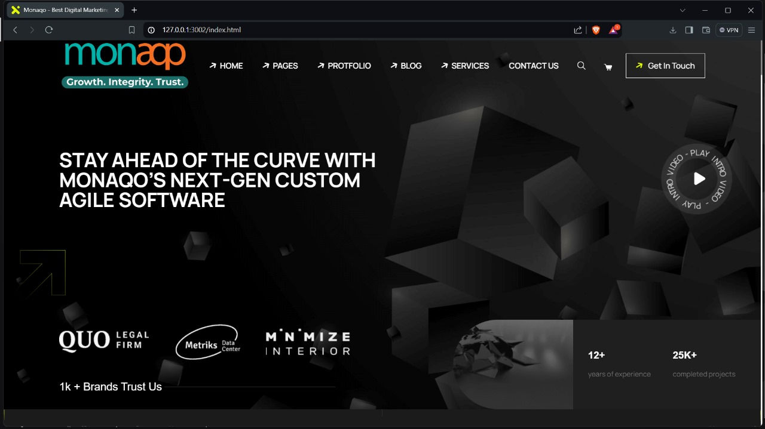

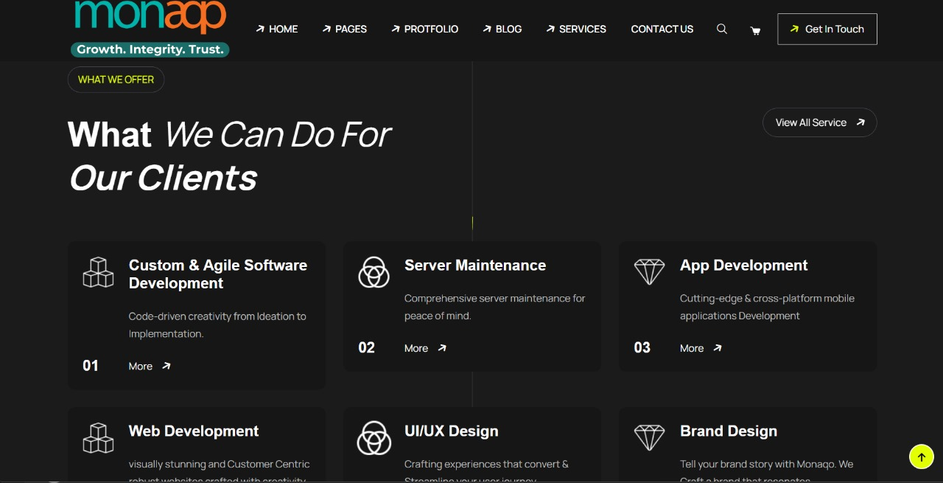

# CONCLUSION

In today’s Web development, a good page design is essential. A bad design will lead to the loss of visitors and that can lead to a loss of business. In general, a good page layout has to satisfy the basic elements of a good page design. This includes color contrast, text-organization, font selection, style of a page, page size, graphics used, and consistency. In order to create a well-designed page for a specific audience. The developer needs to organized and analyze the users’ statistics and the background of the users.

Although it can be hard to come up with a design that is well suited to all of the users, there will be a design that is appropriate for most of the audience. The better the page- design, the more hits a page will get. That implies an increase in accessibility and possible increase in business. A general purposed Web site should use non-frame pages and graphics navigation bar with rollover effects. In addition to the graphic navigation bar with rollover effects, each page should also have a text-only navigation bar for easy control. The developer should also create a Cascading Style Sheet to control the font and font-size and use the style sheet throughout the site to obtain a consistent look and feel.

Web development is the building and maintenance of websites; it’s the work that happens behind the scenes to make a website look great, work fast and perform well with a seamless user experience. Web developers, or ‘dev’, do this by using a variety of coding languages. The languages they use depends on the types of tasks they are preforming and the platforms on which they are working.

Web- development skills are in high demand worldwide and well paid too – making development a great career option. It is one of the easiest accessible higher paid fields as you do not need a traditional university degree to become qualified. The field of web development is generally broken down into front-end (the user-facing side) and back- end (the server side).